Assignment Description
For this assignment complete the following programming exercises. In addition to the requirements stated in these exercises for any classes that you create you should also create a class diagram using UML and a use case diagram.
Complete the following steps:
- Programming Exercise #13 Ch. 17 (p. 1277) - This chapter describes the array implementation of queues that use a special array slot, called the reserved slot, to distinguish between an empty and a full queue. Write the definition of the class and the definitions of the function members of this queue design. Also, write a test program to test various operations on a queue
- Programming Exercise #17 - Ch. 17 (p. 1278) - Write the definition of the class linkedQueueType, which is derived from the class unorderedLinkedList, as explained in this chapter. Also, write a program to test various operations of this class

1 Readme Documentation
This program contains the implementation of queues using arrays, as well as the implementation of queues using unordered linked lists.

2 Flowchart Screen Shots
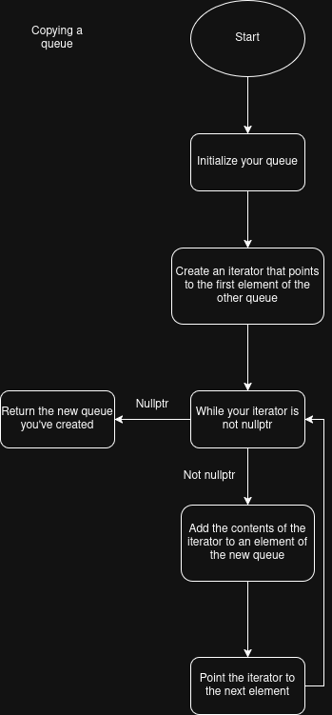

3 UML and Use Case Diagrams
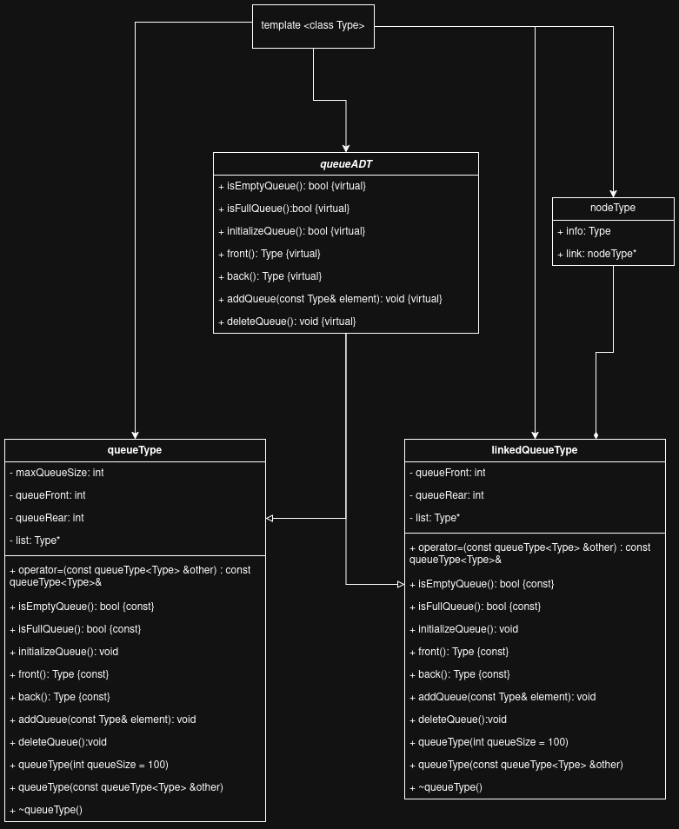
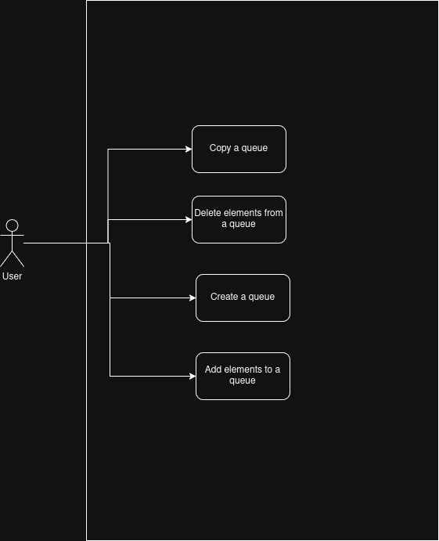

4 Source Code of All files (.h, .cpp)
#include <iostream>
#include <exception>
#include <algorithm>

/*
Name: queue
Author: Wesley Hixon
Date Last Updated:11/16/2025
Purpose: Create a queue from an array
*/

template <class Type>
class queueADT
{
virtual bool isEmptyQueue() const = 0;
virtual bool isFullQueue() const = 0;
virtual void initializeQueue() = 0;
virtual Type front() const = 0;
virtual Type back() const = 0;
virtual void addQueue(const Type& element) = 0;
virtual void deleteQueue() = 0;
};

template <class Type>
class queueType : public queueADT<Type>{
public:
const queueType<Type>& operator=(const queueType<Type> &other){
if(this != &other){
list = new Type[other.maxQueueSize];
maxQueueSize = other.maxQueueSize;
queueFront = other.queueFront;
queueRear = other.queueRear;

std::copy(other.list, other.list + maxQueueSize, list);
}

return *this;
}
bool isEmptyQueue() const{
if(queueFront == queueRear){
return true;
}
else{
return false;
}
}
bool isFullQueue() const{
if(queueFront == (queueRear + 1) % maxQueueSize){
return true;
}
else{
return false;
}
}
void initializeQueue(){
list = new Type[maxQueueSize];
queueFront = 0;
queueRear = 0;
}
Type front() const{
if(isEmptyQueue()) throw(std::runtime_error("Cannot access empty queue."));
return list[queueFront + 1];
}
Type back() const{
if(isEmptyQueue()) throw(std::runtime_error("Cannot access empty queue."));
return list[queueRear];
}
void addQueue(const Type& element){
if(isFullQueue()) throw(std::runtime_error("Cannot add to full queue."));
queueRear = (queueRear + 1) % maxQueueSize;
list[queueRear] = element;
}
void deleteQueue(){
if(isEmptyQueue()) throw(std::runtime_error("Cannot delete from empty queue."));
queueFront = (queueFront + 1) % maxQueueSize;
}
queueType(int queueSize = 100){
maxQueueSize = queueSize + 1;
initializeQueue();
}
queueType(const queueType<Type>& other) :
maxQueueSize(other.maxQueueSize),
queueFront(other.queueFront),
queueRear(other.queueRear),
list(new Type[maxQueueSize])
{
std::copy(other.list, other.list + maxQueueSize, list);
}
~queueType(){
delete[] list;
}
private:
int maxQueueSize;
int queueFront;
int queueRear;
Type *list;
};

int main(){
queueType<int> queue(10);

int i = 1;
while(!queue.isFullQueue()){
queue.addQueue(i);
i++;
}

std::cout << "This is what's in the back of the queue: " << queue.back() << std::endl;

queueType<int> queue2 = queue;
std::cout << "This is what's in the queue: " << std::endl;

while(!queue.isEmptyQueue()){
std::cout << queue.front() << std::endl;
queue.deleteQueue();
}

std::cout << "This is the second queue that was copied from the first queue: " << std::endl;

while(!queue2.isEmptyQueue()){
std::cout << queue2.front() << std::endl;
queue2.deleteQueue();
}
return 0;
}

#include <iostream>
#include <exception>

/*
Name: linked queue
Author: Wesley Hixon
Date Last Updated:11/16/2025
Purpose: Create a queue with a linked list
*/

template <class Type>
class nodeType{
public:
Type info;
nodeType<Type>* link;
};

template <class Type>
class queueADT
{
virtual bool isEmptyQueue() const = 0;
virtual bool isFullQueue() const = 0;
virtual void initializeQueue() = 0;
virtual Type front() const = 0;
virtual Type back() const = 0;
virtual void addQueue(const Type& element) = 0;
virtual void deleteQueue() = 0;
};

template <class Type>
class linkedQueueType : public queueADT<Type>{
public:
const linkedQueueType<Type>& operator=(const linkedQueueType<Type> &other){
if(this != &other){
initializeQueue();

nodeType<Type> *otherIterator;
otherIterator = other.queueFront;

while(otherIterator != nullptr){
addQueue(otherIterator->info);
otherIterator = otherIterator->link;
}
}

return *this;
}
bool isEmptyQueue() const{
if(queueFront == nullptr){
return true;
}
else{
return false;
}
}
bool isFullQueue() const{
return false;
}
void initializeQueue(){
nodeType<Type> *temp;

while(queueFront != nullptr){
temp = queueFront;
queueFront = queueFront->link;
delete temp;
}
queueRear = nullptr;
}
Type front() const{
if(isEmptyQueue()) throw(std::runtime_error("Cannot access empty queue."));
return queueFront->info;
}
Type back() const{
if(isEmptyQueue()) throw(std::runtime_error("Cannot access empty queue."));
return queueRear->info;
}
void addQueue(const Type& element){
nodeType<Type> *temp = new nodeType<Type>;
temp->info = element;

if(isEmptyQueue()){
queueFront = temp;
queueRear = temp;
}
else{
queueRear->link = temp;
queueRear = temp;
}
}
void deleteQueue(){
if(isEmptyQueue()) throw(std::runtime_error("Cannot delete from empty queue."));

nodeType<Type> *temp = queueFront;
queueFront = queueFront->link;
delete temp;
}
linkedQueueType(){
initializeQueue();
}
linkedQueueType(const linkedQueueType<Type>& other){
initializeQueue();

nodeType<Type> *otherIterator;
otherIterator = other.queueFront;

while(otherIterator != nullptr){
addQueue(otherIterator->info);
otherIterator = otherIterator->link;
}
}
~linkedQueueType(){
initializeQueue();
}
private:
nodeType<Type> *queueFront = nullptr;
nodeType<Type> *queueRear = nullptr;
};

int main(){
linkedQueueType<int> queue;
for(int i = -10; i < 0; i++){
queue.addQueue(i);
}

linkedQueueType<int> otherQueue = queue;

std::cout<< "This is your queue: " << std::endl;

while(!queue.isEmptyQueue()){
std::cout << queue.front() << std::endl;
queue.deleteQueue();
}

std::cout << "This is the queue which was copied from the first queue." << std::endl;

while(!otherQueue.isEmptyQueue()){
std::cout << otherQueue.front() << std::endl;
otherQueue.deleteQueue();
}
return 0;
}

5 Three Use Case Screen Shots
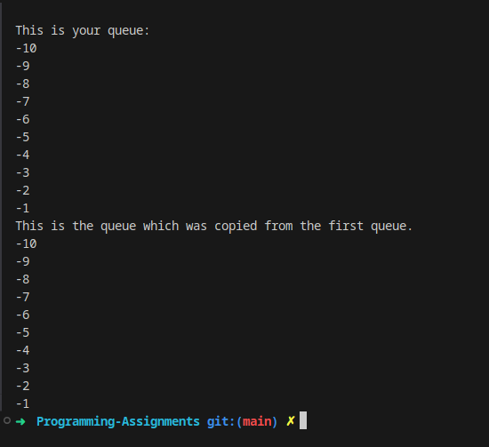
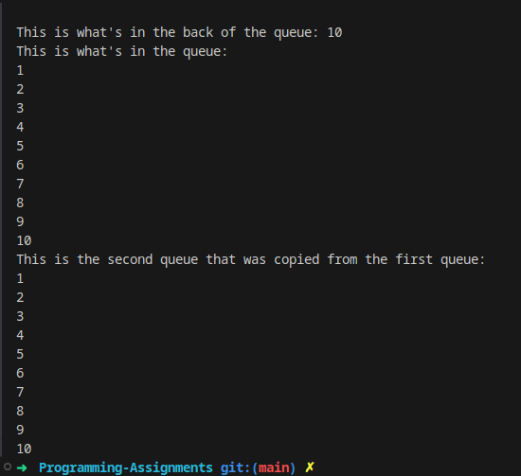

(Optional) GitHub URL

